Navigation
Begin by navigating to the Pay page by clicking on the “Pay” tile

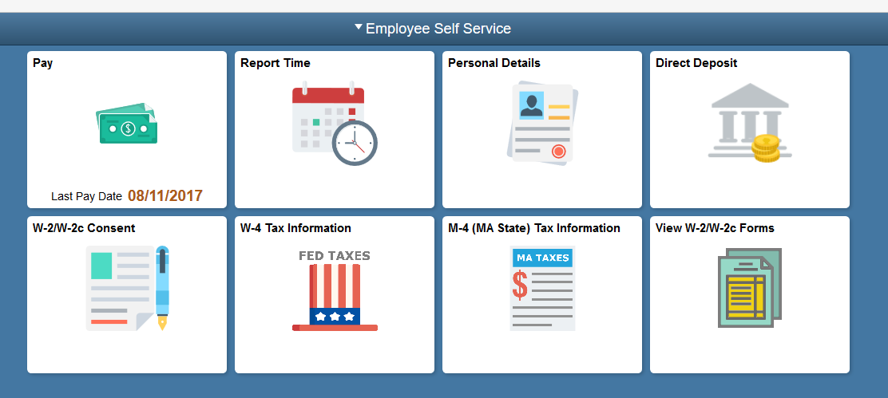

Selecting a Paycheck
Click on the paycheck you would like to view
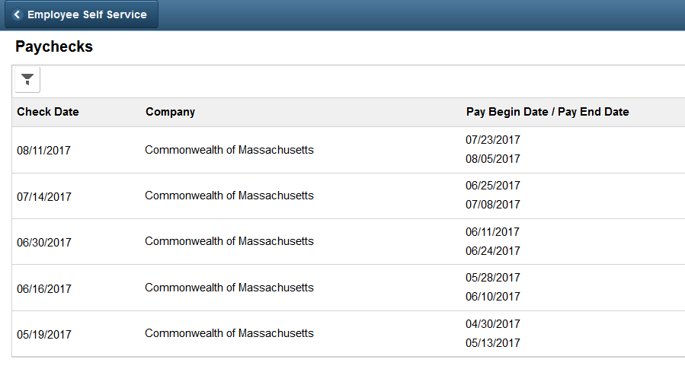

Viewing a Paycheck
The paycheck you selected displays as a .pdf file.
Review the details and scroll down to view additional information about the displayed paycheck.
